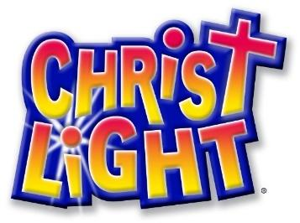

Dear Parents,
Thank you for the opportunity to partner with you in helping your children grow in God’s Word. We know that being around His Word is important to keep our faith nourished and strong. We wanted to share a few things about our Hope Sunday School Program and Christ Light curriculum.
- Sunday School affirms that the home is the center for Christian growth. Parents are the most important people in a child’s life, and learning about God starts at home. We pledge to do our best in supporting you in your children’s spiritual education.

- Stories are taught on a 3 year cycle in order to ensure a strong foundation of Bible knowledge. “Core” stories are taught each year (examples: creation, Jesus’s Birth, Jesus’ resurrection).

- We will provide a memory work calendar to each student and an electronic version will be available on our website. Each week memory work is assigned to be memorized and recited the following Sunday. We will also be emailing out a reminder to our families with the memory verse each Monday.

- Student lessons are given each week in class and will be taken home by the teachers.

- Some things that you can do to support Sunday School, the children, and our teachers:

  - Pray for the program, for the teachers, and for the children.
  - Encourage regular attendance, as we do teach in units and the lessons build on one another.
  - Work on memory work throughout the week, not just on Sunday mornings. The memory work is designed to build up their knowledge for Confirmation classes.

Please contact us if you have any questions or suggestions for Hope’s Sunday School program (Andrew Pedde, 843.245.0586, andrew@hopeofcolumbia.com). Thanks again for the privilege of sharing God’s Word with your children. May God bless you as you continue to train up your child in Christ’s love.

In Christian Love,
Hope Youth Discipleship Team

